- To write a C program to perform 2D basic transformations such as translation, rotation, scaling, shearing and reflection.
Ouput: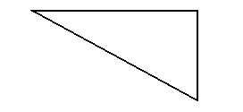
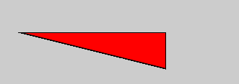
X direction Shearing w.r.t Y reference
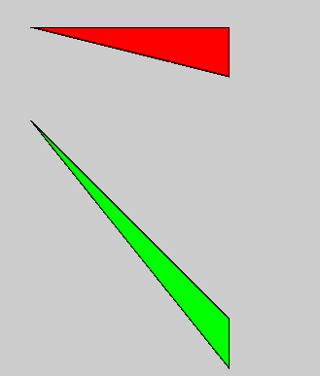

Y direction Shearing w.r.t X reference
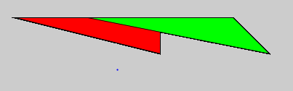

Scaling:
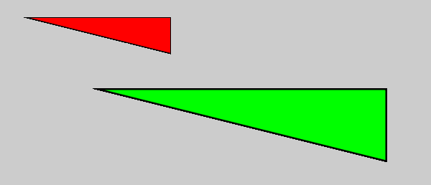
Reflection:
w.r.t line x=y

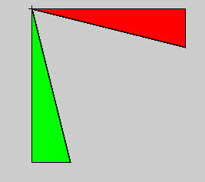
Rotation:
Enter the Degree to rotate the object: 270
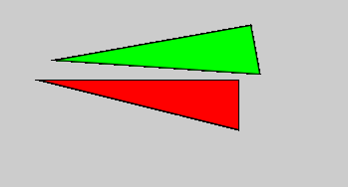
Code:
void setup(){
size(700,700);
}

void draw(){
fill(255,0,0);
triangle(100,100,300,100,300,150);
fill(0,255,0);
//translation
translate(60, 80);
//scaleing
//scale(2.0);
//shearing w.r.t x
//shearX(PI/4);
//shearing w.r.t y
//shearY(PI/4);
//reflection
//triangle(100,100,100,300,150,300);
//rotation
//rotate(270);
triangle(100,100,300,100,300,150);

}

